
EEET4002 – Integrated Design Project
Design Proposal
Project Title | High Frequency Vibration Monitoring Using Machine Learning to Predict Premature Failure
Project Number | Project 11
Group Number | 4
Group Members | Thomas McKay - 17764704
 | Aaliyah Brito - 21545650
 | Louis De Vattimo – 21400380
 | Broderick Madden-Scott - 21605774
 | James Bain - 19776837
Unit Coordinator | Dr Himanshu Agrawal
Unit Instructor | Mr. Rohit Raphael
Submission Date | 22/04/2026

Design Proposal Contributions
1. Executive Summary | James/Brof
2. Problem Definition | James
3. Project Objective | Louis
4. System Requirements | Tom
5. Proposed System Architecture | Tom/James
6. Technical Approach
6.1 Hardware Selection | Louis
6.2 Software Architecture | Aaliyah
7. AI / Data Processing | Brod
8. Bill of Materials | Tom
9. Risk Assessment | Aaliyah
10. Ethical, Safety & Sustainability Considerations | James
11. Testing & Validation Plan | Brod
12. Project Timeline | James
13. Expected Deliverables | James
14. Conclusion | Aaliyah
Editing/Proofing | brod

Table of Contents
Executive Summary vi
1. Problem Definition 1
1.1. Background 1
1.2. Core Engineering Challenge 2
2. Project Objectives 3
3. System Requirements 4
4. Proposed System Architecture 6
4.1. Subsystems Description 6
5. Technical Approach 8
5.1. Hardware Selection Justification 8
5.2. Software Architecture 9
6. AI / Data Processing Strategy 10
6.1. Signals 10
6.2. Machine Learning Strategy. 11
6.3. Non Machine Learning Strategy 11
6.4. System Output 11
7. Bill of Materials 12
7.1. Hardware Requirements 12
7.2. Software Requirements 13
7.3. Scale of Project 13
8. Risk Assessment 14
9. Ethical, Safety & Sustainability Considerations 15
10. Testing & Validation Plan 17
10.1. Testing 17
10.2. Validation 18
11. Project Timeline 19
12. Expected Deliverables 21
13. Conclusion 22
References viii
Appendix I xi
Appendix II - Test Pump xii
Appendix III – Wiring + Code Validation xiii

Table of Tables
Table 1 - Function Requirements 4
Table 2 - Non Functional Requirements 5
Table 3 - Python Architecture 9
Table 4 - Data Structure of MPU6050 10
Table 5 - Time Domain Signals 10
Table 6 - Frequency Domain Signals 10
Table 7 - Induced failure States 11
Table 8 - Initial Expenses 12
Table 9 - Future Costs 13
Table 10 - Software Requirements 13
Table 11 - Risk Management Matrix 14
Table 12 - Electrical Safety 15
Table 13 - Data Privacy 15
Table 14 - Environmental Impacts 16
Table 15 - Sustainability Considerations 16
Table 16 - Staged Development Tests 17
Table 17 - Controlled Computer Fan Testing 18
Table 18 – Controlled Pump Testing 18
Table 19 - Prototype Development Timeline 20
Table 20 - Deliverables 21

Table of Figures
Figure 1 - System Block Diagram 6

Executive Summary
Induction motors and pumps are critical machinery for the mining industry. Unplanned component failures result in significant revenue losses for companies. This report identifies key stakeholders at every company level and the importance of identifying failures before they occur.
Current sensor solutions are unique for specific scenarios, and there is a potential gap in the market for an accessible and affordable, common fault prediction system. A design prototype is proposed for a low cost IoT device that can predict basic routine maintenance faults outside of repair schedules. Key engineering challenges highlight the importance of seamless end-to-end integration, cost and intuitiveness.
The core design architecture comprises 5 sub-systems. They are live sensing, data processing, hardware and software communication, signal processing with ML and visual monitoring of potential faults. These subsystems define the project’s objectives and ultimately shape the development process.
Hardware and component selection is governed by a small budget of $250.00 and therefore, lower cost, off the shelf items are favored over performance, which aligns with the accessibility and affordability design goals. The project estimate comes in at $230.20, roughly 10% below the allowed funding.
Intuition is designed into the firmware and software by using common tooling and a modular, easy to read format, eliminating specialist knowledge and skills. For example, instead of being implemented at the hardware edge, the machine learning model is implemented in PyTorch and uses supervised training with SoftMax probability outputs. The system is then neatly packaged into a desktop GUI.
Risk analysis identifies direct testing and development concerns, such as personal injury and debugging spirals. More importantly, the robustness of the machine learning model, the fault detection system and the significant impact on stakeholders is labelled high risk.
The development timeline is structured for a 9-week turnaround, with the procurement and design report completed at the end of the first week. Planned development testing acts as key milestones and are structured around confirming the 5 sub-system architecture. They are in place to guarantee system robustness and reliability.
Handover of deliverables and prototype demonstration is pitched for the 9th week, commencing May 18th.

Problem Definition

Background
All rotating equipment will undergo thermal fatigue and vibration-induced degradation in its lifetime, which will result in a variety of faults, most of which relate to bearings, gearboxes and rotors.
The mining industry depends on such machinery for all stages of the production cycle, from excavation to haulage, to crushing, to grinding, to screening, and finally processing [1]. A defect relating to any of these parts can cause machinery downtimes, production losses, production halts, and delayed schedules, leading to significant losses in revenue [3].
For example, a 2025 study from Kadyrov showed that unscheduled maintenance of brake assemblies costs companies 56% more per breakdown than during regular scheduled maintenance. Most of these machine failures are unpredictable unless consistent data is being extracted from these motors or pumps [4].
Companies will rely on machinery manuals to get a relatively accurate prediction of when to replace key components [4]. However, this method of maintenance doesn't account for any irregularities and assumes the pump is used in ideal scenarios. A lot of the time, this is never the case due to the broad use case for motors and pumps, as well as, unpredictable circumstances which can affect the health of the machinery [6].
A reliable way to address these issues is to monitor the rotating equipment using sensors, then collecting that data to find trends associated with machinery failure and using that information to predict future defects [7].
This project will develop a prototype IoT device to do just that; live sensing and analysis of motors to predict component degradation prior to failure. Specifically, an induction motor of a water pump, which typically exhibits long term mechanical wear at the impeller, stator, rotor and bearings [2]. In mining, a failing pump motor can have a broad effect on all stakeholders, ranging from entire companies, down to technicians, and kitchen staff.
The users of this system will include fitters, electricians, operators and engineers, meaning that an easy to understand setup and graphical user interface (GUI) will be key to practical application and the primary beneficiary of this system will be the mining company, as improved fault prediction increases uptime of machinery and saves on repair costs.

Core Engineering Challenge
Designing a cost effective, intuitive and data-driven fault prediction system is a significant challenge. The system must sift through large amounts of data to find meaningful fault signatures and produce accurate predictions with enough time to allow intervention before catastrophic failure.
To achieve this, a thorough analysis of the rotating machine’s temperature and its linear and dynamic movement must be undertaken. Linear movements, or vibrations, of a motor are measured via an accelerometer. Any anomalies in the vibrations can be a sign of misalignment, broken bars, or worn bearings within the pump or motor. Temperature monitoring is necessary to capture thermal differences of the machine. A higher temperature can relate to current losses in the motor, which decreases its efficiency [8]. A gyroscopic sensor measures dynamic movements, which can be used to find torsional faults within the machinery [9]. These three sensors combined make for a strong foundation, covering bearing issues, misalignment, efficiency problems and torsion.
The data from these sensors is collected by a microcontroller before transmitting to a computer. A machine learning model, trained in ideal operating conditions, will detect early signs of machine failure by comparing incoming data with historical optimal data. It will then flag any differences and display the data in a series of graphs and readouts within the GUI.
The core engineering challenge is seamless end-to-end integration of multiple elements. For example, placement and sensing of vibration data is one challenge, processing and extracting signal signatures is another challenge, then machine learning, and visual representation provide their own hurdles. Individually, these concepts do not predict machine failure. Collectively they improve up-time and production within industry.
Additionally, accessibility provides further challenges. The GUI must be intuitive but descriptive. Complex plotting and sensor data shouldn’t be the core feedback mode. More informative metrics should be in place. However, defining these metrics will need to balance data truth with user comprehension.

Project Objectives
The primary objective of the project is to design and implement a predictive maintenance prototype which can detect early signs of failure in rotating industrial equipment, i.e. a large mining centrifugal pump. Using machine learning (ML), it is possible to predict when a failure will occur by identifying fault signatures, assisting in the maintenance of the equipment thus saving potentially catastrophic downtime.
Objective 1 – To design and implement a sensing system that can measure high-frequency vibrations, up to 500Hz, and measure the surface temperature. The project uses the MPR 6050 Micro-Electro-Mechanical-Systems (MEMS) sensor and the DS18B20 temp sensor connected to an ESP32 microcontroller.
Objective 2 – To develop a data stream that will capture a continuous stream of data from the two sensors, this data will be held within an integrated memory card and transmitted to the host computer in real time via serial communication. The system must support reliable data logging and export the data sets in a CSV format for more efficient analysis.
Objective 3 – Ensuring proper signal processing techniques will ensure the reliability and efficiency of the data signals, techniques such as FFT spectral analysis, RMS vibration levels and frequency band energy will be explored. These features are generally used to characterise regular rotating machine operation and used in the identification of abnormal behavior.
Objective 4 – By integrating an intelligent machine learning algorithm into our project, we can vastly increase the speed and accuracy of the predictive modelling. Many datasets will be generated from recording different induced failure states and used to train a supervised ML model in Python using PyTorch. The model will analyse features such as vibration and temperature to create a framework for reliable predictive monitoring.

System Requirements
The system requires the measurement of the motor and pump health using vibration and temperature sensors. The information gathered is then to be transferred to a laptop where the data is sorted and then passed to a machine learning (ML) model to monitor the condition of the asset. Tables 1 and 2 outline the functional and non-functional requirements for this signal flow.
Functional Requirements
Sensor Operation | - Measures and transfer data at 1000 samples per second  - Vibration sensor must provide 3 axis acceleration and angular velocity measurements  - Able to communicate via I2C protocol  - Must have own ADC to minimise hardware and programming requirements  - Allow configurable sampling frequency for data optimisation
Microcontroller (ESP32) | - Able to connect to 3 or more sensors and process all incoming data without any bottlenecks  - Ability to store data locally on backup SD card in case of COM port failure  - High speed COM port communication ensuring perfect data transmission  - WIFI capabilities for future development improvements
Communication | - Establish USB serial port communication link with external processing laptop  - Deliver data in correct structure such that host laptop can export directly to CSV file
External Processing Laptop | - USB- Connection point  - Will be able to run a Python scrip to both teach the PyTorch machine learning algorithm and organise the data gathered from the serial port.  - Provide visual display of accelerometer magnitude in real time.  - Build CSV of incoming data stream from communication link  - Store dataset even once program has stopped running
Machine Learning Model | - Supervised training model  - Training on 1s periods of labelled data sets  - Labels identify artificially induced failure states of target motor  - SoftMax probability outputs
User Interface | - Provide easy to interpret magnitude graphs  - Display machine health in terms of percentage generated via machine learning model.  - Generate alerts if failure modes are detected
Table 1 - Function Requirements

Non-Functional Requirements
Safety | - Shall operate at DC levels < 12V  - Electrically isolated from motors high voltage  - Enclosure shall prevent user from accessing conductive parts when in operation  - Sensors will not obstruct cooling airflow or be in contact with rotating parts  - System will generate alerts when failure modes are detected
Power Usage | - Low power mode capabilities to reduce power consumption during periods there the motor is not in operation  - Allow USB-c powered operation for ease of prototyping
Portability | - Small lightweight sensor and controller reduce final size of product.  - Fit within compact enclosure
Working Environment | - Operate in industrial environment with high vibration and electromagnetic interference  - Function at ambient temperatures from 0 - 45$℃$  - IP rating to withstand moisture and dust ingress
Ease of Use | - Require minimal technical skills to install and set up  - Able to be fit to any industry standard pump motor  - Non-invasive mountings to reduce impact on system
Budget Constraints | - Remain within the allocated $250 AUD hardware budget  - Use off the shelf components
Table 2 - Non Functional Requirements

Proposed System Architecture
Figure 1 below provides an overview of the system, its components and their relationships. The proposed system architecture is designed to provide a singular device capable of measuring motor signals, predicting faults and displaying the information on a GUI.
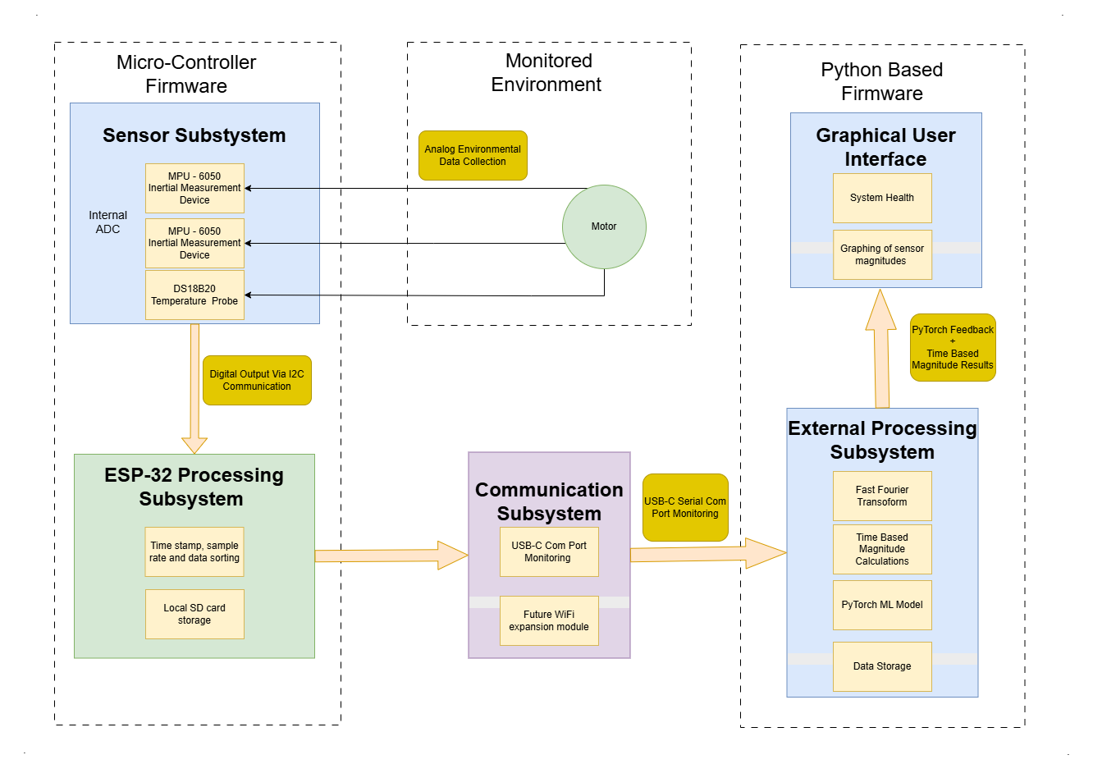
Figure 1 - System Block Diagram

Subsystems Description
Sensor Subsystem
The sensor subsystem is comprised of two MPU-6050 inertial measurement units and one DS18B20 temperature sensor that directly monitors the environmental conditions of the pump’s motor. The MPU-6050s are mounted on both ends of the motor and capture vibration and ambient temperature. Measuring at different locations enables more comprehensive condition monitoring.
The DS18B20 will be located midway down the motor in contact with the metallic cooling fins. This placement enables accurate monitoring of the motor’s change in temperature. Both sensors have on board analog to digital converters (ADC’s), meaning the measurements are sent in digital form meaning no additional hardware or software is required.
ESP-32 Processing Subsystem
The edge processing is carried out by the ESP-32 microcontroller. It performs real time data acquisition form the sensor sub system via I2C with a sample rate up to 1kHz. The ESP-32’s script timestamps the incoming measurements then formats the data, ready for communication via USB-C. The ESP-32 also stores data on the local SD card, as a failsafe in case of communication failure, ensuring that no data is lost and to aid in testing.
Communication Subsystem
The communication subsystem transfers the ESP-32 data to a host laptop via high-speed USB serial communication. The data is specifically structured in a CSV format that the host laptop reads. The ESP-32 includes a built in Wi-Fi module, providing capability for future expansion for the communication system to move away from a wired connection. This feature will not be used during prototyping to reduce the complexity of the communication system.
External Processing Subsystem
Processing is carried out on a laptop running Python based software. The incoming data is buffered in 2 second Numpy arrays and stored in CSV format then processed using frequency and time-based calculations. The processed data is passed to an ML model that has been trained to recognise healthy and unhealthy modes of operation.
User Interface Subsystem
The user interface is responsible for visual feedback and alarm logic, allowing the user to interpret the data in a practical manner. The interface is implemented using a Python and Matplotlib on the external laptop.
Realtime magnitude data combined with the historical trend line will enable users to monitor system health as conditions change. Health based feedback generated by the ML and non ML processing will be presented as percentage-based condition indicators (e.g. Health – 80%) allowing for any user, independent of their training to use the system.
By providing an easy to navigate and interpretive user interface, the subsystem bridges the gap between the complex machine learning model and the real world, allowing for maintenance decisions to be made prior to premature catastrophic failure.

Technical Approach

Hardware Selection Justification
The ESP32 has been chosen as central processing unit for the sensor sub system due to its based on performance and cost. It provides a high-performance dual core-processor and integrated communication interfaces [10]. The ESP32 can handle multiple sensors at once which was a key design aspect. Its clock speeds allow for efficient high frequency capture and usable sample rates, critical for bearing analysis. The ESP32 may not be as reliable or robust as an industrial PLC or some higher end processors but its cost compared with the alternatives is better for prototyping.
There are four key types of sensors used for vibration - accelerometers, velocity sensors, displacement sensors and laser sensors. Each of these sensors have their benefits and drawbacks, the MPU6050 is a popular 6-axis motion tracking sensor which combines a 3-axis gyroscope and a 3-axis accelerometer [11]. These sensors are commonly used for fault identification due to their ability to monitor vibrations across multiple axis’, improving the ability to find imbalances like shaft misalignment or bearing wear. The MPU6050 has inbuilt ADC as well as I2C ports, significantly simplifying the design and wiring.
The tradeoff, MPU6050 sensors are not an industrial grade vibration sensor [12]. The sensor’s resolution is not high enough to capture higher rotational frequency content due to the internal ADC sample rate. Additionally, the MPU6050 lack a fixed external reference, they are prone to gradual drift overtime which will require calibration due to changes in orientation. The 9-axis BNO055 sensor has better functionality of these issues [12], however, the MPU6050 is more cost effective and overall provides easier use when prototyping.
Bearing failure is one of the most common causes of unplanned downtime in manufacturing [13], using a localised temperature sensor is vital for detecting these failures. The DS18B20 temperature sensor is selected for its high accuracy ($±$0.5°C), simple singe wire interface and very low power consumption. Some minor disadvantages of this sensor are a limited temperature range of -55°C to +125°C and requirement of an external pull up resistor [14]. These issues will not affect our project as the temperature of the industrial environment that the system will be operating in will likely not exceed 60°C.
Overall, the selected hardware provides a balance between functionality, cost and complexity while providing sufficient performance for capturing vibration and temperature data when prototyping.

Software Architecture
The software architecture consists of two main components:
- Embedded firmware running on ESP32
- Data analysis in Python
The embedded firmware will handle raw data, while the host computer handles signal calculations and ML training and system diagnosis. The separation between these task ensures the microcontroller focuses on real time sensing within its limitations while the computational analysis is performed externally on a more powerful machine.
The firmware is purely responsible for sensor configuration, data acquisition and communication with the computer. The sensors provide a total of 16 streams of data coming into the ESP32. Each measurement is timestamped and formatted into a structured CSV array. The data is transmitted to a computer through serial communication while also being stored locally on an SD card as a backup. The goals of the firmware are simple enough to rely on three core modules. A configuration module, a processing module and a communications module.
The data analysis software is responsible for data processing, signal processing, ML training and inference and visualisation. Each of these processes will be built into their own Python modules and orchestrated by a main.py function
Module | Description
Main.py | Main orchestration and programmatic flow of DSP/ML environment. One command line argument determining pipeline to execute.
Buffer.py | Building 2 second buffer arrays and slicing 1 second ML and analysis periods. Also handles historical CSV capture for long term analysis.
Signals.py | Time-domain and frequency domain calculations of raw data for feeding to ML and Charting modules.
ml.py | PyTorch classification, Training and inference.
Charting.py | Saved static plotting of signals for testing analysis.
Gui.py | Terminal summary printouts and live visual tracking of data stream.
Table 3 - Python Architecture
The modularized design of both firmware and software provides clear debugging lanes and code flexibility during testing. Moreover, modularity will increase readability by following the core high-level system design in a digestible format.

AI / Data Processing Strategy

Signals
Table 1 shows the data structure of one MPU6050 and DS18B20 sensor to be received via the wired serial comm link from the microcontroller (MCU). Using Python, each column of sensor data will be read into 2-second buffer arrays, of which the most recent second will be used to build the set of common time and frequency signals seen in Tables 2 and 3. [15][16][17].
Sample | mpuAccX | mpuAccY | mpuAccZ | mpuGyrX | mpuGyrY | mpuGyrZ | mpuT | Ds18T
1 | 0.03 | 0.04 | 0.06 | 0.11 | 0.33 | 0.66 | 25 | 29
2 | … | … | … | … | … | … | … | …
Table 4 - Data Structure of MPU6050
Signal | Description
MPU acc mag | The magnitude of the x, y and z accelerometer axes. Combines 3 columns of data into a single signal. RMS will be used for signal conditioning.
MPU gyro mag | The magnitude of the x, y and z gyroscope axis. Combines 3 columns of data into a single signal. Again, RMS will be used for signal conditioning.
MPU temp | The ambient temperature read from the MPU 6050 sensor. A moving average is used to capture trend.
MPU temp grad | The gradient of the ambient temperature moving average. Used to determine the rate of change in ambient temperature at any given time.
DS18B20 temp | The moving average of the DS18B20 temperature sensor at a critical location.
DS18B20 gradient | The gradient of the DS18B20 sensor moving average to determine the rate of change in the targeted area at any given time
Table 5 - Time Domain Signals
Signal | Description
Fundamental mag | The magnitude of the fundamental over time. Increasing or decreasing magnitude can be indicative of different motor loads.
Fundamental Hz | The frequency of the fundamental over time. Similarly, this can also be indicative of changes to the motor loading.
BPFO Bearing Failure | Ball pass frequency on the outer race of bearing. Frequency energy buildup at 3 to 5 times the RPM using FFT.
BPFI Bearing Failure | Ball pass frequency on the inner race of bearing. Frequency energy buildup at 5 to 7 times the RPM using envelope FFT.
Table 6 - Frequency Domain Signals
These tables outline a set of simple and descriptive signals. It is possible to derive more complex and deeper signals, however, for prototyping and proof of concept, the set of signals is deliberately kept simple and small to reduce data blowup when using multiple sensors. Additionally, these variables are selected for compliance with a 1kHz sample rate.

Machine Learning Strategy.
A supervised machine learning (ML) model will be implemented using PyTorch to generate a set of probabilities during motor sensing [18]. Table 4 outlines common failure states that the model will be trained on [17].
Failure | Description
Loose Mounting | Mounting screws/bolts and brackets will be systematically loosened. For example, if 4 bolts hold the motor in place, sensor data will be captured when 1, 2, 3, and 4 bolts are loosened. Targeting vibration sensing.
Max and min loading | Recording the motor running at max or above max rated load to simulate strain in overloading conditions. Conversely, running the motor with little or no load. Targeting overheating and a shifting fundamental magnitude and fundamental Hz.
Off Axis | Tilting the motor off its mounting axis in the Y and Z directions. Targeting gyroscopic sensing and vibration data.
Multiple failures | Combining any of the failure states into a multi-failure state. For example, 2 loose bolts at minimum loading.
Table 7 - Induced failure States
Each failure state will be recorded for 2-3 minutes and labelled, then sliced into 1s sample blocks. For each block, signals will be extracted resulting in 120 – 180 unique sets of data the model can be trained on. The portioning logic is subject to sample rate and determines the resolution of the FFT bearing analysis.
ML outputs will be normalized SoftMax percentages of total health, for example, a healthy but old engine may exhibit a probability split of 80% normal, 10% loose mounting and 10% off axis reading [18].

Non Machine Learning Strategy
Inducing bearing failure for ML labels is unrealistic. Therefore, BPFO and BPFI will be monitored quantitatively [19]. Quantitative analysis of signals will also be used as confirmation and guardrail for ML probabilities.

System Output
Simple threshold gating will determine the output of the system. Logic that combines the ML and non-ML strategies will trigger warning messages associated with decreasing motor health. For example, a “Healthy” message is displayed when both the ML and non-ML strategies have not surpassed any thresholds. Alternatively, “Engine Health: 80%” can be tracked using a scoring system.

Bill of Materials

Hardware Requirements
The table below displays all items ordered through Curtin University, please note that all prices have been rounded up to account for shipping and any additional costs. All suppliers are in Australia and costing is displayed in AUD.
Serial # | Item | Quantity | Supplier | Source | Cost
ESP32 | Microcontroller ESP32 USB c | 2 | Zaitronics | Link | $25
DS18B20 | Temp Sens | 2 | Altronics | Link | $20
 | 4.7K Ohm resistor | Pack of 8 | Altronics | Link | $1
CE07926 | Micro SD card Adapter | 1 | Core Electronics | Link | $5
RR0588 | SD Card- 32Gb | 1 | Office Works | Link | $15
CE07065 | Bread Board | 1 | Core Electronics | Link | $12
WC6027 | Jumper Kit | 1 | Jay Car | Link | $20
MPU-6050 | 3 Axis Gyroscope + Accelerometer | 4 | Core Electronics | Link | $30
P1997C | Usb-c 3.0 2m | 1 | Altronics | Link | $28
H0310 | Enclosure | 1 | Altronics | Link | $36
GN16 | Cable Glands - 16mm | 5 | Altronics | Link | $15
GN20 | Cable Glands - 20mm | 1 | Altronics | Link | $4
 |  |  |  | Total | $211
Table 8 - Initial Expenses
These items make up the core components required to begin bench testing the prototype. Additional expenses will arise once the design is ready to be tested in its final environment.
Serial # | Item | Quantity | Supplier | Source | Cost
W3032 | Shielded Twin Pair Data Cable | 5m | Altronics | Link | $10
1064257 | 20x1.6mm Aluminium Flat Bar | 1 | Bunnings | Link | $5.20
0168406 | 5mm Nuts and Bolts | 1 | Bunnings | Link | $4
 |  |  |  | Total | $19.20
Table 9 - Future Costs
The total accumulated cost of the design amounts to $230.20. This leaves just under 10% of the budget spare allowing for any future costs that have not been predicted.

Software Requirements
All software and libraries to develop, run and test the vibration monitoring device are free to use. When editing software on different operating systems, compatibility can become scattered, therefore, Table 9 will be used as a single source of truth.
Version | Item | Source | Cost
3.13.5 | Python language | Link | Free
2.10.0 | PyTorch | Link | Free
2.4.3 | Numpy | Link | Free
1.17.1 | SciPy | Link | Free
3.0.1 | Pandas | Link | Free
3.10.8 | Matplotlib | Link | Free
3.5 | PySerial | Link | Free
C23 | C language | Link | Free
3.3.6 | Arduino ESP32 | Link | Free
18.3.2 | Visual Studios | Link | Free
9.0.7 | KiCad | Link | Free
Table 10 - Software Requirements

Scale of Project
The budget outlined above is to develop and test a prototype only, the construction and testing is estimated to fall within the $200 - $250 range. For a singular device this cost is high, but this is due to the nature of prototyping. Each component has been ordered individually thus increasing the unit cost to its maximum possible value. The expected cost of future units is expected to decrease exponentially as the prototype is refined and bulk component orders are placed.

Risk Assessment
See Appendix I - Risk Assessment Matrix
Risk Cause | Category | Likelihood | Consequence | Risk Ranking | Mitigation Strategies
Live sensor Measurement Inaccurate | Technical | Possible | Critical | High | Calibrate sensors and optimise placements. Optionally, apply signal filtering to reduce electrical noise.
Data loss or corruption from SD card failure | Technical | Possible | Major | High | Log data to both SD card and serial output and perform regular backups.
Electrical shock or contact with rotating components during testing | Safety | Likely | Critical | High | Use protective covers on rotating parts and disconnect power during setup.
Defective machine learning model | Technical | Possible | Critical | High | Supplement ML methods with non-ML sensing of temperature and vibration increases and decreases.
Insufficient data for machine learning analysis | Technical | Possible | Moderate | Moderate | Extend data collection and run simulations. Supplement with external datasheets if needed.
Delays in coding, debugging, or hardware setup affecting project timeline | Scheduling | Possible | Moderate | Moderate | Establish project milestones and allow contingency time for troubleshooting and testing.
Sensor malfunction, damage or misplaced | Technical | Possible | Low | Low | Handle hardware with care. Using only what is necessary. Stocktaking.
Table 11 - Risk Management Matrix

Ethical, Safety & Sustainability Considerations
Electrical Safety
Problem | Solution
Grounding of components | Label wires so incorrect placement of wires or parts can be avoided, e.g. sharing the ground of the components with the motor, 415V.
Wire vibration fatigue, heat degradation and abrasion | Using the correct rated wires that will suit the environmental conditions.  Making sure wire connections are strong (soldered or trusted connector) to avoid loose wires.
Mounting of sensors to motor | Using a metal bracket tapped into the housing to mount the sensors .
Motor heat affecting sensors | Making sure the sensors are rated to withstand the temperature of the motor.
Dust and debris affecting components | Using an enclosure to protect the microcontroller and surrounding connections.
Fire hazards | Keep the area clear of any flammable objects and keep a close watch on initial startup and setup of the system
Table 12 - Electrical Safety
Data Privacy
Problem | Solution
Privacy of data being collected | Data is kept private by not using Bluetooth or Wi-Fi to send and receive the motor information. Data is sent via cable directly to the pc, so there is no way for data to be stolen online
Table 13 - Data Privacy
Environmental Impacts
Problem | Solution
Unexpected machinery faults causing major machinery damage, meaning more frequent and costly part replacements | Using a predictive maintenance approach will mean machinery will be replaced less, meaning less manufacturing, which indirectly lowers emissions. Predictive maintenance will lead to parts not needing to be express delivered, meaning parts could come in with regular shipments, which will indirectly lower emissions
Table 14 - Environmental Impacts
Sustainability Considerations
Problem | Solution
Other solutions are expensive and specialised | Using widely available parts means replacement and repair is cheap and easy. Instead of sending parts away to be fixed or having to get a specialty part made
Sensor degradation and replacement | Using sensors that can handle the environment they are exposed to, will mean less to replace
Incorrect use leading to hardware damage | Giving customers access to documentation of the system to avoid incorrect use and damaging of parts
Table 15 - Sustainability Considerations

Testing & Validation Plan

Testing
Table 3 outlines a chronological order of staged testing checkpoints for clean hardware, firmware and software design integrations. Some of these tests are dependent on prior tests being completed. For example, test 7 relies on test 4 to be completed. All these tests should be passed before full integration of all elements.
# | Test | Description
1 | Online simulation | Testing of ESP32 connections using online simulator. Testing of ESP32 code using online sim  See Appendix IV for Simulation figure and output
2 | Hardware/firmware | Initial power up of hardware and firmware. Blink light code confirmed functional
3 | Hardware/firmware | Initial sensor axis confirmation using controlled sensor movements and serial.print() to terminal.
4 | Firmware/software | Handshake tests confirming MCU to Python communication via serial.print() and terminal printing.
5 | Software | Testing of DSP math and visualisation using online data.
6 | Software | Training of mock ML models using data found online to validate pipelines.
7 | Firmware/software | Testing of pipelines with CSV of initial test data capture from sensors. Validating data parity from MCU capture with Python side analysis.
Table 16 - Staged Development Tests
The prototype’s design features will be tested in a controlled environment by walking through the entire end-to-end setup and live monitoring of computer fan failures. Table 4 outlines the specific tests for failure mode identification. These tests will require specific model training on fan failure data labels.
# | Failure mode test | Description
1 | Loose mounting | During live monitoring, mounting screws will be systematically undone to mimic a failing motor mount and confirm identification.
2 | Max and min loading | Using fingers or a soft pad, pressure can be applied to fan blades for max loading. Fan blades can be shortened or cut for mid loading readings.
3 | Off Axis | Simply, tilting the blade in y or z directions.
4 | Multiple failures | A combination of any of the failure modes. The goal here is identify whether the ML model requires data labels of multi-failure modes, or, if the model can accurately identify multiple failures using the isolated training labels.
Table 17 - Controlled Computer Fan Testing

Validation
Image 1 of Appendix II shows an irrigation pump that will be used to test the system in a more realistic yet still controlled environment. For an extended period, the prototype will monitor sensors attached to the pump at critical points [5], and record and monitor ML and non-ML outputs. This test validates the design by proving robustness. Robustness is proven by following the controlled test procedure for the realistic test environment.
# | Failure mode test | Description
1 | Loose mounting | Motor mounting bolts will be loosened during operation to simulate fixture failure
2 | Max and min loading (in a fan test, broken blades or blade obstruction) | Flow rate of fluid to the pump can be controlled via valves on the suction and discharge side. Closing the suction valve will simulate loss of prime, a failure mode that can cause significant damage to the pump. Closing the discharge valve will simulate pipe blockage or valve failure.
3 | Off Axis | Motor mounts will be loosened and spacers added on one corner of the mount to tilt the motor.
4 | Multiple failures | Combination of failure modes #1-3
Table 18 – Controlled Pump Testing

Project Timeline
There is a 9 week window from the submission of this report to the prototype demonstrations. March 16th is the start of week 1, with presentations marked for the week starting May 18th. A Gantt chart of the project is linked in Appendix I
Start week | Milestone | Description | Completion Week (end of)
1 | Design Agreement &  Procurement | - Submission of the design report, which represents a source of truth and plan for the ongoing development of the prototype. Design features are explored using online resources and preliminary software and firmware development based on datasheets and known analysis techniques.  - All items stipulated in the BOM are received. | 1
2 | Initial Hardware and Firmware Development completion | - Initial power up and wiring of mcu with sensors.  - Initial firmware flashing of mcu/sensor configuration code.  - Completion of TEST#2 and TEST#3. | 2
2 | Initial software development completion | - Building and testing dsp and ML methods against dummy data acquired online.  - Completion of TEST#5 and TEST#6 | 2
2 | Building of computer fan testbench | - The system will be validated in a controlled environment with computer fans prior to uncontrolled validation. | 4
3 | Firmware to Software Handshake confirmation | - Development of communication protocol and data handling over text based serial comm-link.  - Completion of TEST#4. | 3
3 | Software Firmware  Hardware  Version 1 | - Completion of all modules for Python software and mcu firmware outlines in section 5.2.  - Completion of hardware housing and sensor mounts | 5
4 | Validation of initial data capture | - Sensing and recording of initial hardware configurations and software build, demonstrating a clean, sense, communicate and analysis pipeline.  - Completion of TEST#7. | 6

Start week | Milestone | Description | Completion Week (end of)
5 | ML Training and inference in controlled environment | - Capturing and labelling of failure states for ML Training and inference using comp fans  - Successful identification of failure states and system sign off ready for uncontrolled environment  - Inclusive of software and firmware updating | 7
5 | Draft of handover report | - Drafting of initial structure and bullet pointing of key concepts for handover report due for submission with the demonstration. | 6
7 | Uncontrolled environment testing | - Validation of design using uncontrolled environment.  - Successful training and inference of pump failure states outlined in Table 18. | 8
7 | Final report & demonstration preparation | - Finalisation of handover report  - Collating of visual aids for final demonstration.  - Final firmware/software/hardware revisions  - Handover of deliverables.  - Presentation. | 9
Table 19 - Prototype Development Timeline

Expected Deliverables
# | Deliverable | Items
3 | Hardware | Wired and functional prototype package of:  - ESP32 development board  - MPU6050 sensors  - DS18B20 sensors  Test bench consisting of:  - Mounted computer fans for specific failure captures  - Hardware documentation:  - ESP32, MPU6050 and DS18B20 datasheets  - Line diagram and port selection of hardware connections
2 | Firmware | C source code for:  - ESP32 configuration  - Sensor configurations  - I2C connection to sensors  - Serial printing of sensor data  - Makefile  Firmware Documentation:  - Readme  - Firmware dependencies (ESP32duino)  - Examples  - Known bugs
1 | Software | Python source code for:  - Capturing and labelling sensor data  - Training and calibrating ML models  - Live and static visualisation and static analysis.  Software Documentation:  - Readme  - Software dependencies, e.g, NumPy  - Example static outputs  - Example live outputs  - Known bugs
4 | User Documentation | Guidelines on:  - Hardware setup  - Sensor placement  - Faults being monitored  - Fault interpretation.  - Safety procedures
5 | Closeout report. | Recommendations on:  - Target stakeholders  - Industry application,  - Improvements & restraints.
Table 20 - Deliverables

Conclusion
Unplanned failures in rotating machinery remain a significant challenge within the mining industry, leading to costly downtimes, reduced productivity, and inefficient maintenance practices. This project proposes a predictive maintenance system that utilises temperature and vibration monitoring to identify early signs of mechanical and electrical degradation in pumps and induction motors.
The solution integrates sensors with an ESP32 to enable continuous data acquisition, real time transmission, and reliable data logging. Compared to traditional time-based maintenance approaches, this system provides condition-based insights, allowing faults to be detected earlier and maintenance to be scheduled more efficiently. The incorporation of machine learning further enhances the system’s capability to identify abnormal operating patterns with greater accuracy.
The design adopts a modular architecture, supporting flexibility in sensor integration and future system expansion. As a prototype, it serves as proof of concept to validate the feasibility of predictive monitoring before full scale deployment. The proposed approach demonstrates strong potential for field applications and provides a clear pathway towards commercial scalability.

References

[1] A. K. Soni, I. L. Muthreja, and R. R. Yerpude, Principles and Practice in Mining Engineering. Boca Raton, FL, USA: CRC Press, 2024. [Online]. Available: https://www.taylorfrancis.com/reader/download/17b73f5e-1a57-47af-b6d9-573f2b437cb3/book/pdf?conte xt=ubx
[2] T. Garcia-Calva, D. Morinigo-Sotelo, V. Fernandez-Cavero, and R. Romero-Troncoso, "Early Detection of Faults in Induction Motors-A Review," Energies, vol. 15, no. 21, p. 7855, 2022, doi: 10.3390/en15217855. [Online]. Available: https://mdpi-res.com/energies/energies-15-07855/article_deploy/energies-15-07855-v2.pdf?version=1666866140
[3] M. Irfan et al., "A Novel Feature Extraction and Fault Detection Technique for the Intelligent Fault Identification of Water Pump Bearings," Sensors, vol. 21, no. 12, p. 4225, 2021, doi: 10.3390/s21124225. [Online]. Available: https://mdpi-res.com/sensors/sensors-21-04225/article_deploy/sensors-21-04225.pdf?version=1624188396
[4] A. Kadyrov, A. Kukesheva, M. Daribzhan, and A. Aidraliyev, "Development of a Methodology for Optimizing Repair Interval Timing for Mining Equipment Units," Eng, vol. 6, no. 12, p. 362, 2025, doi: 10.3390/eng6120362. [Online]. Available: https://mdpi-res.com/eng/eng-06-00362/article_deploy/eng-06-00362-v2.pdf?version=1765536533
[5] P. Nunes, J. Santos, and E. Rocha, "Challenges in predictive maintenance - A review," CIRP Journal of Manufacturing Science and Technology, vol. 40, pp. 53-67, 2023, doi: 10.1016/j.cirpj.2022.11.004. [Online]. Available: https://www.sciencedirect.com/science/article/pii/S1755581722001742
[6] Garcia, "IEEE Xplore document (arnumber 8575146)," IEEE Xplore, 2019. [Online]. Available: https://ieeexplore.ieee.org/stamp/stamp.jsp?tp=&arnumber=8575146
[7] S. Esakimuthu Pandarakone, Y. Mizuno, and H. Nakamura, "A Comparative Study between Machine Learning Algorithm and Artificial Intelligence Neural Network in Detecting Minor Bearing Fault of Induction Motors," Energies, vol. 12, no. 11, p. 2105, 2019, doi: 10.3390/en12112105. [Online]. Available: https://mdpi-res.com/energies/energies-12-02105/article_deploy/energies-12-02105.pdf?version=1559377738

[8] A. Glowacz et al., "Detection of Deterioration of Three-phase Induction Motor using Vibration Signals," Measurement Science Review, vol. 19, no. 6, pp. 241-249, 2019, doi: 10.2478/msr-2019-0031. [Online]. Available: https://reference-global.com/article/10.2478/msr-2019-0031
[9] A. R. Askari, L. Gelman, and A. D. Ball, "Novel Investigation of Influence of Torsional Load on Unbalance Fault Indicators for Induction Motors," Sensors, vol. 25, no. 7, p. 2084, 2025, doi: 10.3390/s25072084. [Online]. Available: https://mdpi-res.com/sensors/sensors-25-02084/article_deploy/sensors-25-02084-v3.pdf?version=1743399085
[10] Espressif Systems, "ESP32 Datasheet," 2025. [Online]. Available: https://documentation.espressif.com/esp32_datasheet_en.pdf
[11] Dejan, "Arduino and MPU6050 Accelerometer and Gyroscope Tutorial," HowToMechatronics, Apr. 9, 2019. [Online]. Available: https://howtomechatronics.com/tutorials/arduino/arduino-and-mpu6050-accelerometer-and-gyroscope-tutorial/
[12] ODG, "Is the MPU6050 Still Worth It? Our Review," Origin IC, Oct. 24, 2025. [Online]. Available: https://www.origin-ic.com/blog/is-the-mpu6050-still-worth-it-our-review/48162#heading-2 [Accessed: Mar. 20, 2026].
[13] AMD Machines, "Thermal Monitoring for Predictive Maintenance," Mar. 4, 2025. [Online]. Available: https://amdmachines.com/blog/thermal-monitoring-for-predictive-maintenance/ . [Accessed: Mar. 20, 2026].
[14] Adrian, "DS18B20 Temperature Sensor: Pros and Cons," AllPCB, Sep. 10, 2025. [Online]. Available: https://www.allpcb.com/allelectrohub/ds18b20-temperature-sensor-pros-and-cons. [Accessed: Mar. 20, 2026].
[15] P. Kolok et al., "Low-Cost IoT-Based Predictive Maintenance Using Vibration," Sensors, vol. 25, no. 21, p. 6610, 2025, doi: 10.3390/s25216610. [Online]. Available: https://pmc.ncbi.nlm.nih.gov/articles/PMC12609400/#sec3-sensors-25-06610
[16] H. Lifsitch et al., "Vibration sensor dataset for estimating fan coil motor health," Data in Brief, vol. 56, p. 110866, 2024, doi: 10.1016/j.dib.2024.110866. [Online]. Available: https://pmc.ncbi.nlm.nih.gov/articles/PMC11402634/#refdata001

[17] S. J. Bruinsma, R. D. Geertsma, R. Loendersloot, and T. Tinga, "Motor current and vibration monitoring dataset for various faults in an E-motor-driven centrifugal pump," Data in Brief, vol. 52, p. 109987, 2024, doi: 10.1016/j.dib.2023.109987. [Online]. Available: https://www.sciencedirect.com/science/article/pii/S235234092301017X
[18] Rumn, "Softmax, but Explained to a High Schooler," Medium. [Online]. Available: https://rumn.medium.com/softmax-but-explained-to-a-high-schooler-77f413a8fc09 . [Accessed: Mar. 20, 2026].
[19] Vibromera, "What Are Bearing Fault Frequencies? Defect Detection," [Online]. Available: https://vibromera.eu/glossary/bearing-fault-frequencies/ . [Accessed: Mar. 20, 2026].
[20] Government of Western Australia, "Risk Assessment Matrix Provided by the Department of Environment Regulation," [Online]. Available: https://www.health.wa.gov.au/~/media/Files/Corporate/general%20documents/Clandestine%20drug%20labs/PDF/Risk-Assessment-Matrix-Provided-by-the-Department-of-Environment-Regulation.pdf . [Accessed: Mar. 20, 2026].

Appendix I

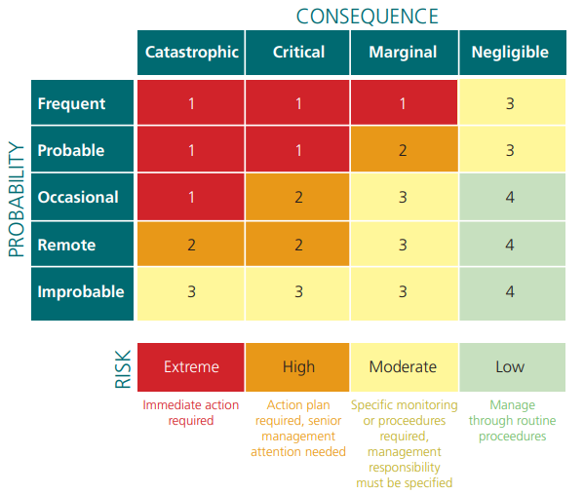

Appendix II - Test Pump

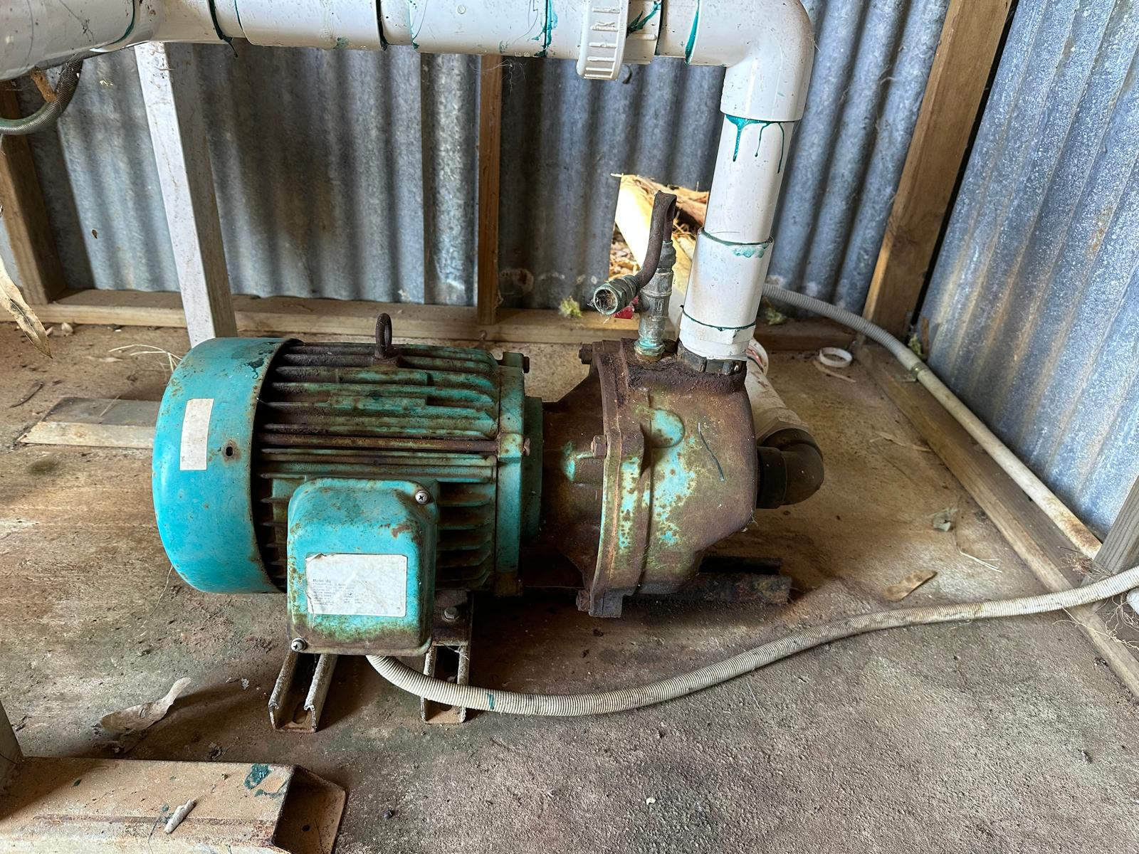

Appendix III – Wiring + Code Validation
